

Faculty of Computers and Artificial Intelligence

Computer Science Department

2021/2022

**CS 395 Selected Topics in CS-1**

**Research Project**

Report Submitted for Fulfillment of the Requirements and ILO’s for Selected Topics in CS-1 course for Fall 2021

Team No. ****

|  |  |  |  |
| --- | --- | --- | --- |
|  | ID | Name | Grade |
|  |  |  |  |
|  |  |  |  |
|  |  |  |  |
|  |  |  |  |
|  |  |  |  |
|  |  |  |  |
|  |  |  |  |

Delivered to:

**Dr. Wessam El-Behaidy**

**Eng. Islam Gamal**

**Eng. Muhammed Kamal**

I. NUMERICAL DATASET

1. Project Introduction

* 1. **Dataset Name**

Car Engine Type Prediction

* 1. **Number of classes and their labels**

3 classes (0: gasoline , 1: diesel , 2: electric)

* 1. **Dataset Samples Numbers**

38531 record

* 1. **Training, Validation and Testing**

Training :26972

Test:11559

Validation:5395

1. Implementation Details
   * 1. **Extracted Features**

Num of feature: 17

Names of feature: [manufacturer_name, model_name, transmission, color, odometer_value, year_produced, engine_fuel, engine_has_gas, engine_type, engine_capacity, body_type, has_warranty, state, drivetrain, price_usd, is_exchangeable, number_of_photos, up_counter, duration_listed]

Num of dimensions: 17

* + 1. **Cross-validation**

20%

* + 1. **Artificial Neural Network (ANN)**
* **Hyper-parameters**

(Specify all the hyper-parameters (initial learning rate, optimizer, regularization, batch size, no. of epochs…) with their specified value in implementation)

initial learning rate = 0.001

optimizer = adam

regularization = dropout

batch size =32

num of epochs = 50

* + 1. **Support Vector Machine** **(SVM)**
* **Hyper-parameters**

(Specify all the hyper-parameters (optimizer, regularization, …) with their specified value in implementation)

1. Models Results

**For each model you should show all these results for your model on testing data** (loss curve, accuracy, confusion matrix, ROC curve)

* 1. **ANN Result**Chart

     Description automatically generated**Chart

     Description automatically generated**

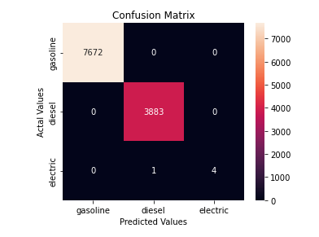

* 1. **SVM Results**

II. IMAGE DATASET

1. Project Introduction

* 1. **Dataset Name**

(What is the dataset used?)

* 1. **Number of classes and their labels**

(Specify number of classes and their labels.)

* 1. **Dataset Images Numbers and size**

(The total number of images in dataset and the size of each.)

* 1. **Training, Validation and Testing**

(The number of images used in training, validation and testing.)

2. Implementation Details

* + 1. **Extracted Features**

(How many features were extracted, their names, the dimension of resulted features)

* + 1. **Cross-validation**

(Is cross-validation is used in any of implemented models? If yes, specify the number of fold and ratio of training/validation)

* + 1. **Artificial Neural Network (ANN)**
* **Hyper-parameters**

(Specify all the hyper-parameters (initial learning rate, optimizer, regularization, batch size, no. of epochs…) with their specified value in implementation)

* + 1. **Support Vector Machine** **(SVM)**
* **Hyper-parameters**

(Specify all the hyper-parameters (optimizer, regularization, …) with their specified value in implementation)

3. Models Results

**For each model you should show all these results for your model on testing data** (loss curve, accuracy, confusion matrix, ROC curve)

* 1. **ANN Results**
  2. **SVM Results**